**CSC 1101 – Problem Solving and Programming Laboratory**

**Lab 9 – Omar Faruk**

**25 points – Due October 6, end of lab**

**a)** Save this document with your name and the lab assignment number somewhere in the file name.

**b)** Type/paste your answers into the document.

**c)** Submit this document to the Canvas item where you downloaded this document.

You are hired to write a C++ console to calculate the speed limit of a car. The limit system of that state is given below:

|  |  |
| --- | --- |
| Speed (Miles/Hr) | Message |
| 1-9 | Okay on parking |
| 10-29 | okay on side streets |
| 30-59 | Okay on major streets |
| 60-69 | Okay on freeway |
| 70-79 | You are already speeding |
| 80-89 | Over speeding. Slow the car |
| <0 or >90 | Invalid speed |

The range of speed is between 0 to 90. A staff of a traffic control office will use your program. In that case, the staff can do mistake by putting the speed higher than 90 and lower than 0. If that happens, your program will print an error and prompt the user to put the speed again. You should use switch statement to handle the conditions in your code. Moreover, the number of case statements you need is less than 10. Take the input speed as an integer and make it smaller number by doing mathematical operation. Print the statements with setw() and alignments like the sample input/output:

**Sample Input/Output:**

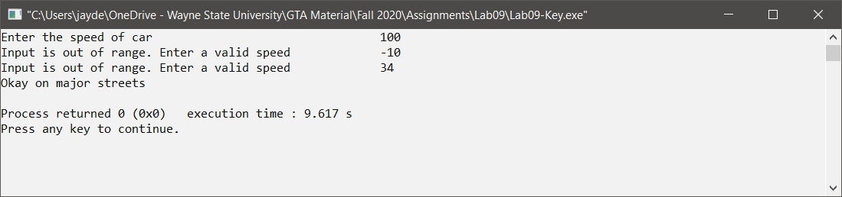

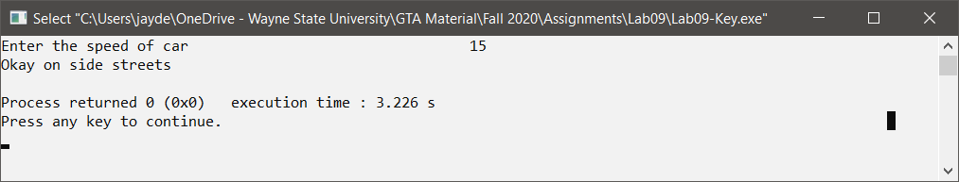

*[your program code here]\**

//==========================================================

//

// Title: Speed Limit Calc

// Course: CSC 1101

// Lab Number: Lab 09

// Author: Omar Faruk

// Date: 10/06/20

// Description:

// Creating a speed limit calc

//

//

//==========================================================

#include <cstdlib> // For several general-purpose functions

#include <fstream> // For file handling

#include <iomanip> // For formatted output

#include <iostream> // For cin, cout, and system

#include <string> // For string data type

using namespace std; // So "std::cout" may be abbreviated to "cout"

int main()

{

// Declare Constants

const int COLMFT1 = 50;

const int COLMFT2 = 20;

// Declare variables

int speed;

int range;

// Write to screen

cout << "Welcome to Speed Limit System!" << endl;

cout << "--------------------------" << endl << endl;

cout << setw(COLMFT1) << left << "Enter the speed of car: ";

cin >> setw(COLMFT2) >> right>> speed;

while (speed < 0 || speed > 90)

{

cout << setw(COLMFT1) << left << "Input is out of range. Enter a valid speed:";

cin >> setw(COLMFT2) >> right>> speed;

}

range = speed / 10;

switch (range)

{

case 0:

cout <<setw(COLMFT1) << left

<< "Okay on parking"

<< endl;

break;

case 1:

cout << setw(COLMFT1) << left

<< "Okay on side streets"

<< endl;

break;

case 2:

cout << setw(COLMFT1) << left

<< "Okay on side streets"

<< endl;

break;

case 3:

cout << setw(COLMFT1) << left

<< "Okay on major streets"

<< endl;

break;

case 4:

cout << setw(COLMFT1) << left

<< "Okay on major streets"

<< endl;

break;

case 5:

cout << setw(COLMFT1) << left

<< "Okay on major streets"

<< endl;

break;

case 6:

cout << setw(COLMFT1) << left

<< "Okay on freeway"

<< endl;

break;

case 7:

cout << setw(COLMFT1) << left

<< "You are already speeding"

<< endl;

break;

case 8:

cout << setw(COLMFT1) << left

<< "Over speeding. Slow the car"

<< endl;

break;

default:

cout << setw(COLMFT1) << left

<< "Unknown Speed"

<< endl;

}

// Show application close

cout << "\nEnd of my Application" << endl;

}

*[your program output here]\*\**

